22.32: a)
b) Since the field is parallel to the surface, 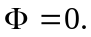
c) Choose the Gaussian surface to equal the volume’s surface. Then: 750 – EA= in the positive -direction. Since 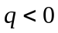 we must have some net flux flowing in so 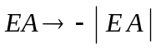 on second face.
d) but we have E pointing away from face I. This is due to an external field that does not affect the flux but affects the value of E.

